Trent Giever

CS &141

Ch 2

4/9/2020

Problem # 9

Code:

/\*

Programmer: Trent Giever

Assignment Chapter: 2

Purpose: MPG Calculator

Date modified: 04/09/2020

IDE/Tool used: NetBeans 8.2

\*/

package ch2.pkg1;

import static java.lang.System.out;

import java.util.Scanner;

/\*\*

\*

\* @author trgie

\*/

public class Ch21 {

/\*\*

\* @param args the command line arguments

\*/

public static void main(String[] args)

{

Scanner in = new Scanner(System.in); //creates scanner obj

out.println("MPG Calculator Program");

out.println("Please enter the number of miles driven: ");

double miles = in.nextInt(); // gets in users miles

out.println("Please enter the number of gallons consumed: ");

double gallons = in.nextInt(); //gets in users gallons

double MPG = miles / gallons; // MPG calculation

out.println("Your MPG is: " + MPG); //display the results

}

}

Snip:

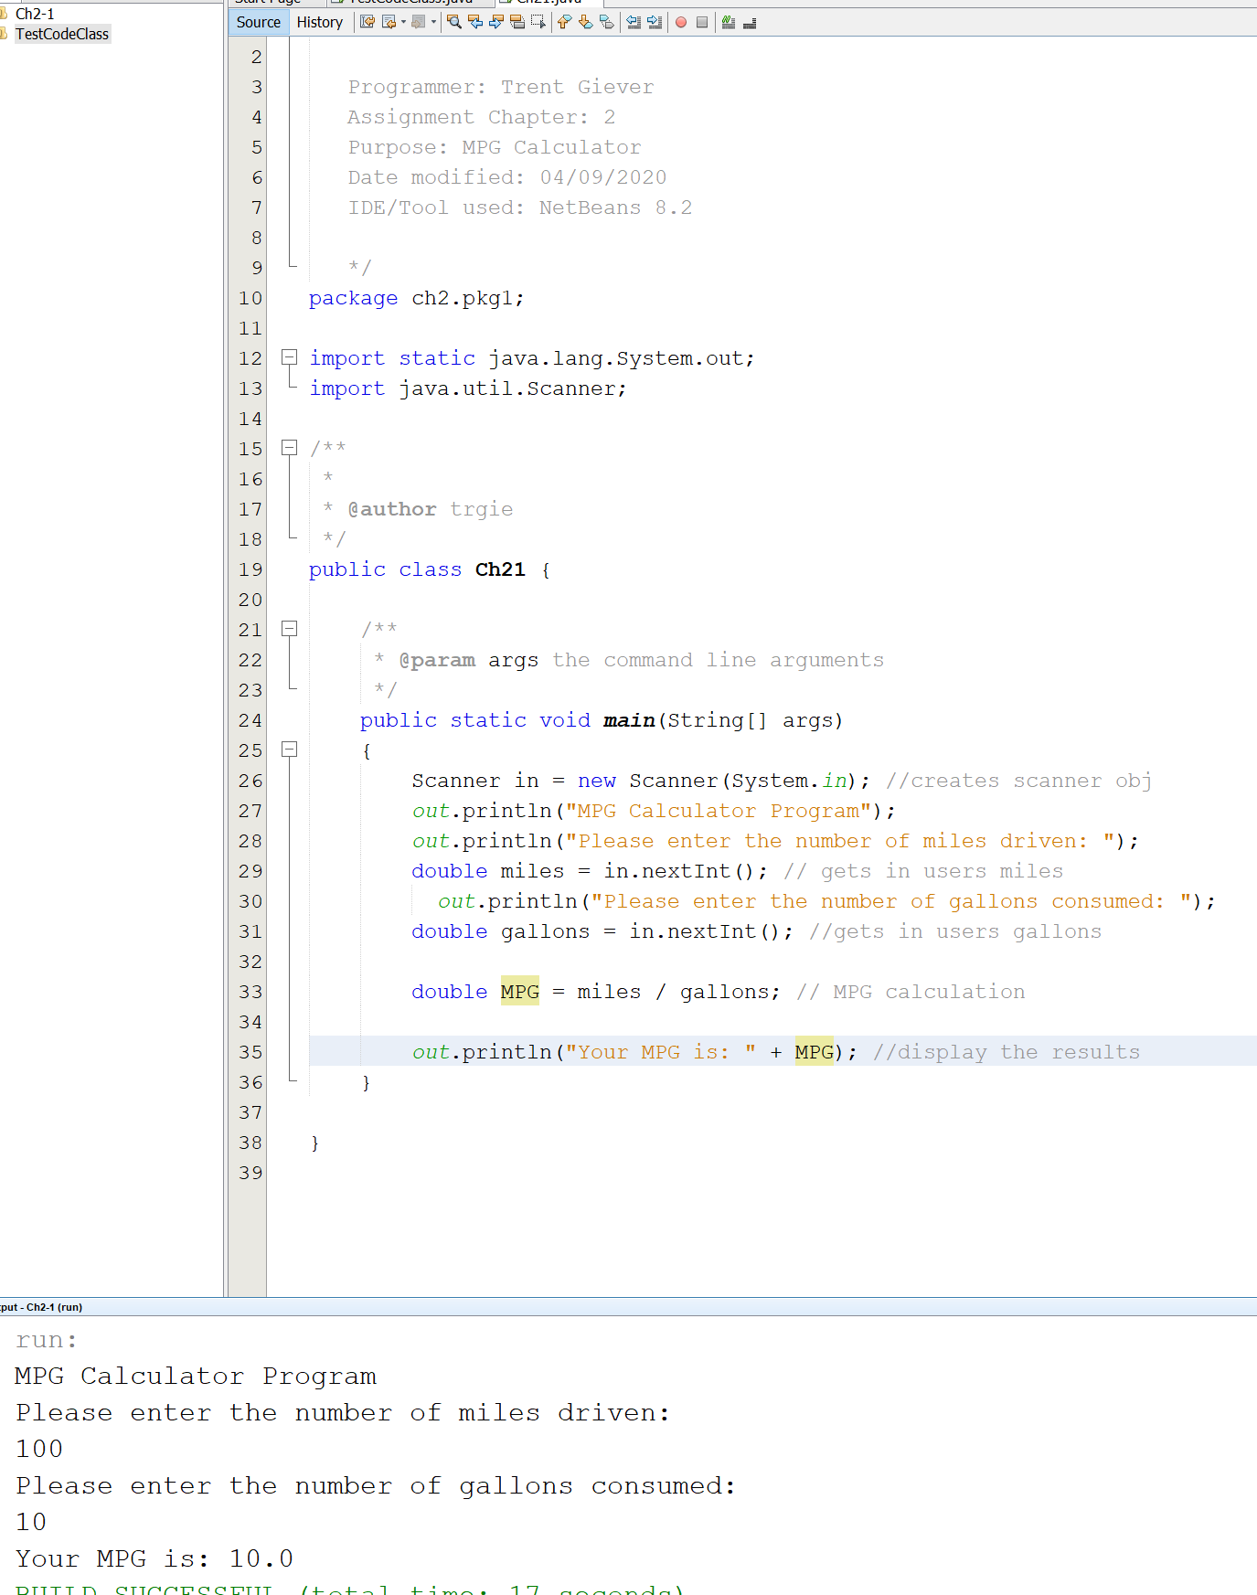

Program #13

Code:

/\*

Programmer: Trent Giever

Assignment Chapter: 2

Purpose: Restaurant Bill

Date modified: 04/10/2020

IDE/Tool used: NetBeans 8.2

\*/

package ch2.pkg2;

import static java.lang.System.out;

import java.util.Scanner;

public class Ch22 {

public static void main(String[] args)

{

Scanner in = new Scanner(System.in); //creates scanner obj

out.println("Restaurant Bill Program");

out.println("Please enter the amount of the bill: ");

double subtotal = in.nextInt(); // gets in users bill

final double TAX = .075, TIP = .18; //final values for the tax and tip

double tip = subtotal \* TIP; // gets the amount of the tip

double tax = subtotal \* TAX; //gets the amount of the tax

double total = subtotal + tip + tax; // total calculation

out.println("Your tip is: $" + tip); //display the results

out.println("Your tax is: $" + tax); //display the results

out.println("Your total is: $" + total); //display the results

}

}

Snip:

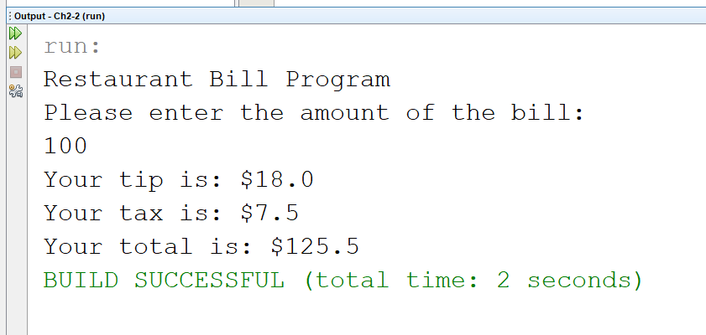

Program # 17

Code:

/\*

Programmer: Trent Giever

Assignment Chapter: 2

Purpose: Word Game

Date modified: 04/10/2020

IDE/Tool used: NetBeans 8.2

\*/

package ch2.pkg3;

import javax.swing.JOptionPane;

public class Ch23

{

public static void main(String[] args)

{

String pname="", age="", city="", college="", profession="", animal="", aname="";

pname = JOptionPane.showInputDialog("Enter your name");//person name

age = JOptionPane.showInputDialog("Enter your age");

city = JOptionPane.showInputDialog("Enter city");

college = JOptionPane.showInputDialog("Enter your college");

profession = JOptionPane.showInputDialog("Enter your profesion");

animal = JOptionPane.showInputDialog("Enter a type of animal");

aname = JOptionPane.showInputDialog("Enter a pets name");//animal name

JOptionPane.showMessageDialog(null, "There once was a person named " + pname +

" who lived in " + city + ". At the age of " + age + ", " + pname +

" went to college at " + college + ". " + pname + " graduated and went to work as a "

+ profession + ". Then, " + pname + " adapted a(n) " + aname +

". They both lived happily ever after!");

}

}

Snip:

